# **LCR Technology Guide for Church Services**

## **General**

**Computer Logins:**

AV Password: 322ohio

*IF Admin privileges are needed, eg, to install software:*

lcr_admin Password: admin

* Mac Mini is currently set to login at startup with the AV account

**YouTube Studio Login:**

[lcrstreaming@gmail.com](mailto:lcrstreaming@gmail.com) Password: streaming322

## **PowerPoint Slides for Projection**

Open slides(todays_date.pptx) on left laptop and present slideshow to have slides present on screens.

* The laptop dual screens should be set for extended screens

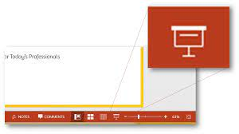

## **The right –side “screen” of the laptop dual display is the screen up in front (and the ‘confidence’ monitor on the n]balcony which faces the pastor and band). By default it is displaying the laptop desktop background. Currently the laptop is set to have a black desktop background, and so the front screen will appear empty or black. If the laptop desktop background is changed to a graphic, the graphic will display on the front (and confidence) monitor.**

## **Livestream**

1. Start the MAC Mini pc in the booth. It is set to login as user AV. If it does not login to a desktop, login to Livestream pc within the booth using AV login above. The streaming pc is an Apple Mac Mini, with power switch at back corner. *You may need to turn the wireless keyboard and mouse on prior to login.*
   * If you get no response from the KB and/or mouse (it can take 10-30 seconds for the Mac to recognize the wireless connnections, so be a little patient):
     + Press the white 3 button on the keyboard
     + Ensure there are some lights on the devices
     + Chnge non-working device to a corded device fro the extras pile
     + Change battery(ies)
2. Open both the “LCR YouTube Studio” and the “Companion” apps from the desktop (see icons below

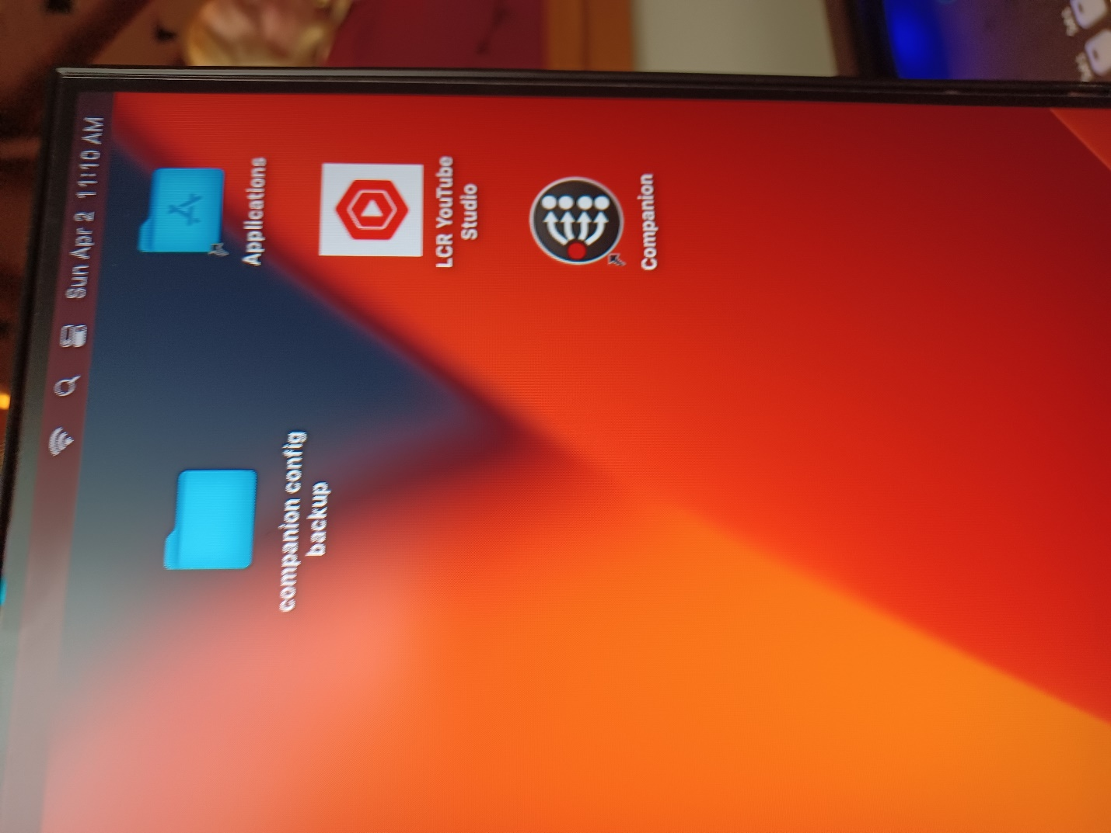

1. With YouTube up and ready, press the “On Air” button on the ATEM. After pressing the “On Air” button there will be a 10 second or so delay, then YouTube should acknowledge and be on air.
   1. *If that doesn’t work:*

## Start the BlackMagic ATEM software (YouTube refers to it as the streaming software) and be sure it is set (or set) to "On Air" (click the On Air” button.



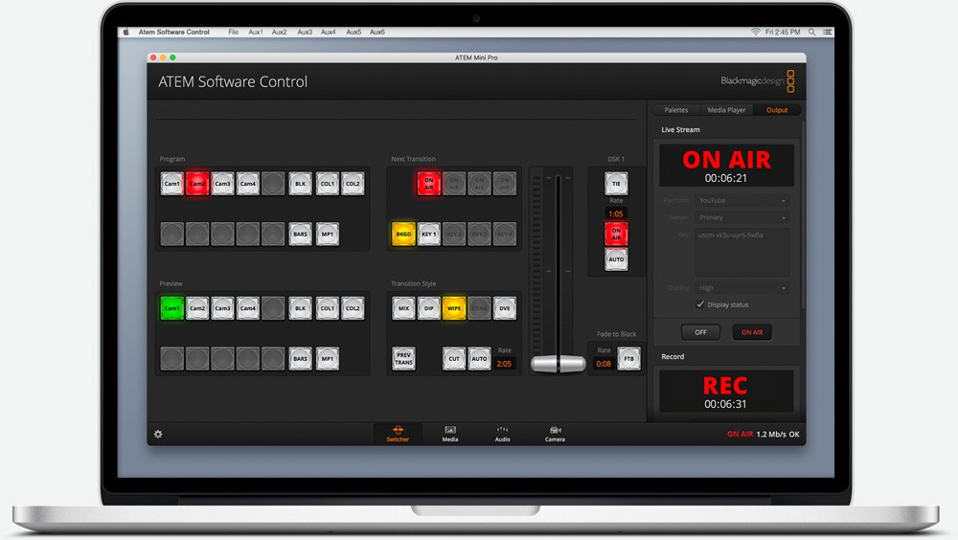

1. In YouTube, click “Go Live” to begin the stream
2. **Once opened, both the Stream Deck and ATEM Mini Pro should be turned on (lights of keys on, see below).** These keypads control various functions of the livestream.

Stream Deck = camera positions

ATEM Mini Pro = screen transitions

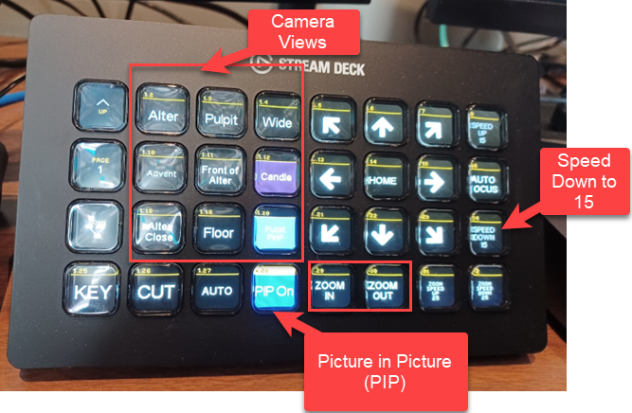

Additional Buttons are available

DO NOT USE THE PIP POSITIONING BUTTONS ON THE ATEM!! USING THEM WILL REVERT THE PIP TO THE DEFAULT SMALL SIZE!!!!! Good practice would be to use the StreamDeck Buttons for PIP On and Off, however you may use the ATEM PIP On and Off, BUT ONLY On and Off. NOTE: There are 2 new buttons – PIP Upper Right and PIP Upper Left which affect PIP position.

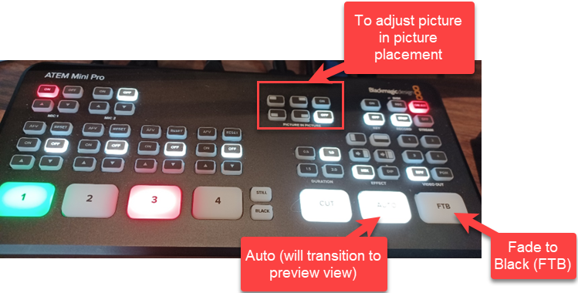

**GAYLE: PLEASE REMOVE THE BALOON AND OULTLINE FOR ADJUST PICTURE IN PICTURE. (You may even want to put a white box over the PIP keys as they should be covered up on the ATEM), AND MAKE NEW BALLOONS AS SUGGESTED BELOW. And then maybe remove the text below referring to auto and cut. Should have a balloon for each ie: CUT balloon: “Cut transition from Preview to Program”, Auto balloon: “Dissolve transition from Preview to Program”**

**Before you begin, on StreamDdeck, you’ll want to reduce the speed of the camera movement down to 15.**

This controls how quickly the camera moves when you adjust its placement. Hit the “speed down” button until it goes down to 15.

If that’s a good speed, I’m sure this could somehow be set to default to 15, or at lest a button made to do it one touch. WIP!

Other key functions:

PIP = picture in picture (shows the main camera/screen with the slides smaller in the corner) – simply hit the PIP button to turn on or off. Use the PIP position buttons to change where the pip appears.

FTB = fade to black

Auto = will dissolve from the preview screen to the alternate screen (use this to switch from PowerPoint view to camera view)

Cut = will cut from the preview screen to the alternate screen (use this to switch from PowerPoint view to camera view)

**The left monitor shows the preview view and live (Program) views.**

A preview of what is “on deck/standby” shows on the left, and the live program is on the right. What’s live is outlined in red, what’s on standby is in green.

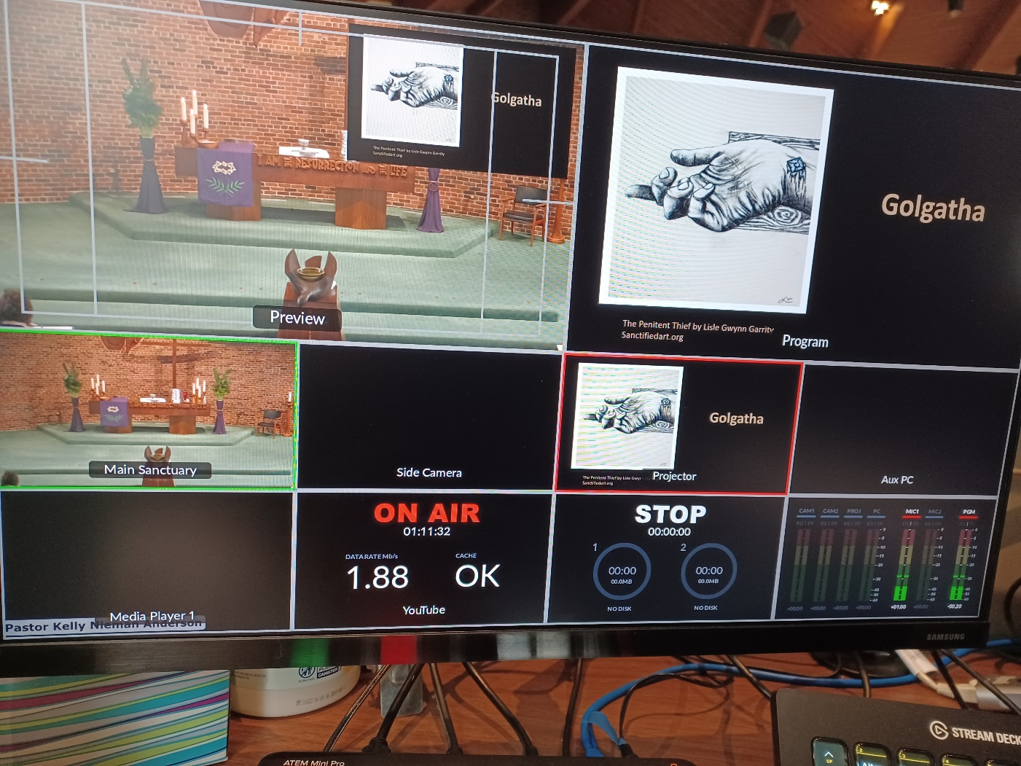

**From YouTube, select the service that you’d like to livestream. Once ready, begin the livestream by clicking the “Go Live” button.**

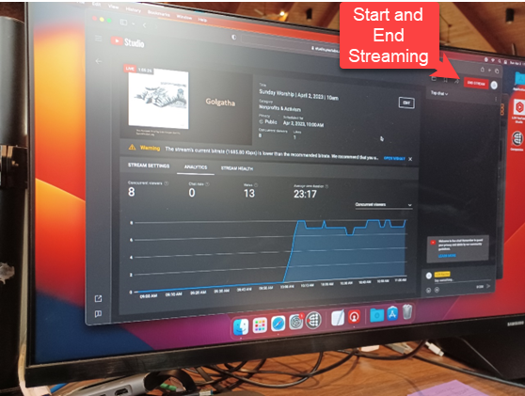

1. **When the service is done, wait for the livestream preview on YouTube to show your last slide.** Once this happens, hit the “FTB” or Fade to Black button on the stream deck.
   1. Then, hit the “end stream” button on YouTube to end the livestream.

## **Troubleshooting**

**If there is no camera feed shown:**

* There should be a bookmark in Safari for the Panasonic PLZ. Open a new tab and click that bookmark. This will take you to the camera interface. On that screen select 'Power On'
* If there is no bookmark, open a new tab in Safari and enter the IP Address 192.168.1.250. This will bring you to the camera interface. Select 'Power On'

**If the “Picture in Picture” screen reduces size:**

* **Press StreamDeck PIP Off to turn off PIP**
* **Press the StreamDeck key PIP Upper Right or PIP Upper Left**
* **Press the Streamdeck PIP On/Off button to bring back PIP in the larger size**
* Make sure the laptop dual screen setup is set to ‘Extended”
  + Right-click on a blank part of laptop desktop, Display Settings, Display, Multiple Display, Display #2 should be “Extended”